**The Global Burden of Maternal Bereavement:**

**Indicators of the Cumulative Prevalence of Child Loss**

**Abstract**

**Background** We provide country-level estimates of the cumulative prevalence of mothers bereaved by a child’s death in 170 countries and territories.

**Methods** We generate indicators of the cumulative prevalence of mothers who have had an infant, under-five-year-old, or any-age child ever die by using publicly available survey data in 89 countries and an indirect approach that combines formal kinship models and life table methods in 81 countries. We label these measures the maternal cumulative prevalence of infant mortality (mIM), under-five mortality (mU5M), and offspring mortality (mOM) and generate prevalence estimates for 20-44-year-old and 45-49-year-old mothers in 170 countries and territories.

**Result*s*** In several Asian and European countries, the mIM and mU5M are below 10 per 1000 mothers yet exceed 200 per 1000 mothers in several Middle Eastern and African countries. Global inequality in mothers’ experience of child loss is enormous: mothers in high-mortality-burden African countries are more than 100 times more likely to have had a child die than mothers in low-mortality-burden Asian and European countries. In more than 20 African countries, the mOM exceeds 500 per 1000 mothers, meaning it is typical for a surviving 45-49-year-old mother to be bereaved.

**Discussion** The study results reveal enormous global disparities in mothers’ experience of child loss and draws attention to the need for more research on the downstream mental and physical health risks associated with parental bereavement.

**Key questions**

**What is already known?**

● In sub-Saharan African countries, maternal indicators of the child mortality burden show that—even as infant and child mortality rates decline—having experienced a child’s death remains a common maternal experience.

● Child death is known to adversely affect mothers’ lives, yet we lack a systematic, global analysis of the maternal burden of child loss.

**What are the new findings?**

● Our results offer estimates of the maternal cumulative prevalence of infant (mIM), under-five (mU5M), and all offspring mortality (mOM) for 20-44-year-old and 45-49-year-old mothers in 170 countries, providing a new view of the burden of premature death across the globe.

● Global inequality in mothers’ experience of child death is enormous: mothers in select African countries are more than 100 times more likely to have had a child die than mothers in select Asian or European countries.

**What do the findings imply?**

● Quantifying maternal experiences of child loss offers a new sense of the population burden of child death, reveals how disparate maternal conditions are worldwide, and attests to the need for additional individual-level research on the consequences of child loss for families.

**BACKGROUND**

Infant and child mortality rates have declined steadily worldwide over the last fifty years.1 Even with periods of stagnant improvement, and persistent between- and within-country inequality, the global trends signify notable progress for children and their parents. The improvements in annualized rates of infant and child mortality, however, do not offer insights into parents’ cumulative experiences of child loss—raising questions of the global burden of parental bereavement. A child’s death can have serious and long-lasting consequences for parents2–4, but estimates of the population prevalence of bereaved parents are available only for select sub-Saharan African countries.5 This study reveals the high burden of child loss in the region: in multiple sub-Saharan African countries as recently as 2015, upwards of one-third of mothers have experienced a child death.5 It is unclear whether such high levels of maternal bereavement characterize other low- and middle-income countries, and how they compare to levels of maternal bereavement in high-income countries.

In this article, we offer a global perspective on maternal bereavement by providing the first population-level estimates of the prevalence of bereaved mothers in 170 countries. We generate three indicators of the cumulative prevalence of mothers who have had an infant, under-five year old, or any-age child die. We label these indicators: the maternal cumulative prevalence of infant mortality (mIM), under-five mortality (mU5M), and offspring mortality (mOM).5 We calculate these measures separately for two groups of mothers: those in the peak of their reproductive years (20-44-year-old mothers) and those nearing the end of their reproductive careers (45-49-year-old mothers). To achieve global coverage, we generate these indicators through a combination of direct estimation approach using publicly available survey data and an indirect estimation strategy using publicly available age-specific fertility and mortality schedules.6

These country-level measures of maternal bereavement demonstrate how infant, child, and adolescent mortality conditions accumulate and form a corresponding shadow population of bereaved parents—a group of parents that deserve public health attention. Global inequalities in the burden of family bereavement reflect disparate health environments, but may also facilitate future disadvantage by leaving parents vulnerable to the grief, trauma, and adverse outcomes associated with bereavement.7–11 A child’s death can have profound and lasting influence on parents’ wellbeing, including their mental health and physical health and longevity.2–4,12–20 The health consequences associated with bereavement have been shown to be especially severe for mothers, and the adverse effects of grief can persist for years—even decades.16 Child loss can also adversely impact other aspects of parents’ lives, including the health and stability of their relationship with one another.3,18 The guilt, blame, stigma, stress, and relationship strain associated with child loss has been documented across diverse cultural contexts, including in settings where child loss is tragically normative, and perhaps even an anticipated, aspect of motherhood.21–25 By demonstrating the size and distribution of child loss across the globe, these metrics will render visible an inequity that has been overlooked in the global mortality literature.

In offering a global overview of maternal bereavement, the study also clarifies that a population’s parental bereavement burden cannot be inferred from current mortality indicators because it is patterned by past and present mortality and fertility conditions. In terms of mortality conditions, the legacy of higher child and adolescent mortality years earlier linger in the birth histories of older mothers, contributing to higher lifetime experiences of bereavement. Past and present death rates dictate not just the likelihood of losing a child but also how many bereaved mothers have survived versus how many have also died prematurely, thereby erasing their account of child loss. The degree to which child deaths are dispersed across families versus concentrated among a disadvantaged few further dictates the total societal reach of these experiences. In terms of fertility, a parents’ cumulative risk of experiencing a child die is determined by exposure: whether a mother has experienced a child die is undeniably influenced by the number of children she has.26 Thus, this global portrait of maternal bereavement offers a fundamentally new perspective of the mortality landscape, supplementing current global health metrics.

**METHODS**

**Data sources**

Survey-based Estimates of Maternal Bereavement

We first generate indicators of the maternal cumulative prevalence of child death directly using microdata from nationally representative surveys that collect full reproductive histories from female respondents. Then, to expand country coverage beyond what is achievable with publicly available survey data, we introduce an indirect approach that uses formal demographic methods to estimate the prevalence of bereaved mothers in a population.

Our direct estimation strategy makes use of three data sources specifically. For 56 countries across Africa, Asia, Europe, Latin America and the Caribbean, and Oceania (see **table s1**), we leverage data from the Demographic and Health Surveys (DHS) program. DHS data come from nationally representative household surveys that feature large sample sizes (usually between 5,000 and 30,000 households) (see <https://dhsprogram.com/>). DHS interviewers collect detailed information from various household members, including reproductive history data from women ages 15-49. To offer recent estimates of child loss, we restrict our analysis to surveys collected between 2010 and 2018.

For 32 additional countries in Africa, Asia, Europe, and Latin America and the Caribbean where recent DHS survey data are not available (see **table s1**), we make use of data from the Multiple Indicator Cluster Surveys (MICS). MICS is an international household survey program developed and supported by UNICEF (see <https://mics.unicef.org/>). MICS interviewers similarly collect data from various household members, including reproductive history calendars from women ages 15-49. Again, we focus on surveys collected between 2010 and 2018.

For the United States, we make use of the National Survey of Family Growth (NSFG) (2013-17). NSFG is a nationally representative survey of ever-married women in the civilian, non-institutionalized population of the U.S. (see <https://www.cdc.gov/nchs/nsfg/index.htm>). NSFG interviews are conducted in-person and feature reproductive history calendars. Because the NSFG included women 45 years and older in only one survey round, and because of the small sample for this age group, we use these data only for 20-44-year-old mothers and rely on our indirect approach for older mothers.

In each survey, we restrict the analytic sample to women who have had at least one live birth (i.e., the women ever exposed to the risk of child death). Among these women, we make use of data collected through their reproductive history calendars, specifically information on the vital status of each child ever born and, for those deceased, the age at death. Note that given data constraints, we do not include pregnancy loss in our estimates, but instead focus only on deaths occurring after a live birth. **Table S1** lists all sample sizes, countries, data sources, survey years, and well the data source and survey year for each country.

To estimate the maternal cumulative prevalence of infant mortality (mIM), we sum the number of mothers who had a child die before age one among those who ever had a live birth and express this per 1000 mothers. To estimate the maternal cumulative prevalence of under-five mortality (mU5M), we do the same for mothers who ever had a child die before reaching age five. Finally, the maternal cumulative prevalence of offspring mortality (mOM) indexes all experiences of child death, regardless of the child’s age at the time of death. We calculate these indicators separately for women of reproductive age (20-44-year-old mothers), and those completing their reproductive years (45-49-year-old mothers). Note that we exclude 15-19-year-old mothers from our primary analyses given that a relatively select group of teenagers had given birth. That is, more than 95% of women in DHS and MICS surveys had their first child at age 20 or older. However, among 20-44-year-old mothers a smaller share had children above age five; thus, we calculate the mOM for 45-49-year-old mothers only due to this excessive censoring. All survey-based estimates of the mIM, mU5M, and mOM shown here are appropriately weighted.

Kin-Cohort-based Estimates of Maternal Bereavement

Not all countries regularly collect publicly available surveys with detailed reproductive histories, thus, we supplement our survey-based estimates using a an indirect, kin-cohort approach.6 To do so, we make use of publicly available demographic data from the United Nations World Population Prospects (UNWPP) (see <https://population.un.org/wpp/>). Note that our estimates are specifically drawn from UNWPP demographic data from 1950 through 2016.

To generate synonymous period estimates of the maternal cumulative prevalence of infant, under-five, and offspring death as those generated with survey data, we extend the Goodman-Keyfitz-Pullum kinship equations from mathematical demography27,28 to non-stable populations with changing demographic rates and combine them with standard life table methods. The kin-cohort method allows us to estimate the cumulative number of infant, child, and offspring deaths experienced by an average woman born in cohort *c* surviving to age *a* given a set of cohort mortality and fertility schedules:

(1)

where for infant deaths, for child deaths and 00 for all-age offspring deaths. We restrict the female reproductive age to , so that for all cases.

To determine the prevalence of bereaved women in a population, we start by considering the age-specific probability that an average woman will experience the death of a child:

(2)

where is the hazard rate of experiencing the death of a child younger than *k* 29. Given , the probability of losing a child, we create a life table 30 with a unit radix and use its survivorship column to define the fraction of women aged *a* in cohort *c* who ever experienced the death of a child younger than *k:*

Next, we account for the mortality of women by considering the fraction of women in each birth cohort that survived up to each age. With this information, we can solve the proportions of women (per 1,000 women) who have ever lost one or more children younger than *k*:

. (3)

To tailor the estimate to reflect an equivalent measure for mothers, we rescale our estimates using a similar life-table approach. We consider fertility as a “hazard rate” to approximate the number of women that remain childless after experiencing a set of age-specific fertility rates. The fraction of women who have had one or more live births is approximated as 1 minus the fraction of women who have had no live births. We can now define, for a given cohort, the proportion of mothers (per 1,000 mothers) who have ever lost one or more children younger than *k*:

. (4)

Eq.4 provides single-age cohort estimates of the prevalence of bereaved mothers. We convert these cohort estimates to period estimates so that they can interpreted exactly as the direct survey estimates. This allows us to estimate the mIM, mU5M, and mOM for 20-44-year-old mothers and 45-49-year-old mothers. Note that our kin-cohort estimates refer to calendar year 2016—the modal year of survey coverage. We generated indicators for the 81 countries and territories that we lack survey data for, and that have a population over one million, resulting in total coverage of 170 countries and territories. **Table s1** denotes our estimation strategy for each point estimate (results generated using the kin-cohort approach are italicized).

**Robustness Check: The Comparability of Estimates**

Although we prioritize the survey-based estimates and only rely on the indirectly generated kin-cohort estimates for countries or territories where survey data were unavailable, in supplementary analyses, we compared estimates using both strategies. We rely heavily on the kin-cohort approach in all regions except Africa. We are fortunate to have such high survey coverage in this region given that UNWPP data for several African countries relies on model life tables, weakening the utility of the kin-cohort approach in this region. Thus, in these supplementary analyses, we focus on the 45 non-African countries and territories with survey data. As shown in **figure S1**, we found high correspondence: the two estimation strategies produced values that were, on average, less than a fraction of a one % different for 20-44-year-old mothers (mIM and mU5M) and between 3-5% for 45-49-year-old mothers (mIM, mU5M, mOM).

When there are discrepancies between the survey-based prevalence estimates and those calculated using the kin-cohort approach, the latter strategy tends to yield slightly higher estimates. We suspect that this is driven by the fact that the indirect kin-cohort approach cannot account for the clustering of deaths to specific mothers.31,32 Thus, a limitation of the study is that because we rely on the kin-cohort method for several countries in Asia and Europe, our estimates of the child loss burden in these low-mortality-burden regions may be slightly artificially elevated. Thus, any comparisons drawn between these countries and African countries—which tend to be higher-mortality-burden countries where we have almost complete survey coverage—will be conservative.

Even as it is most common for the kin-cohort approach to yield slightly higher estimates, in select cases, the kin-cohort method produces estimates that are lower than the survey-based ones (see **figure S1**). This serves as a reminder that child deaths can also be underestimated in the survey data, and perhaps more accurately tabulated using life tables. Moreover, survey programs can inadvertently underrepresent hard-to-reach populations, including those affected by civil unrest or conflict–populations that are known to have a higher burden of child loss.33–35

**Patient and public involvement**

We use secondary data for the analysis. Therefore, no patient consent was needed.

**RESULTS**

**Maternal burden of infant mortality**

**Figure 1** maps the mIM for 20-44-year-old mothers, offering a global portrait of the prevalence of young mothers who have experienced an infant death. In 13 countries and territories, fewer than 5 per 1000 of young mothers have ever lost an infant (Hong Kong, Japan, Singapore, South Korea, Czech Republic, Slovenia, Finland, Iceland, Italy, Norway, Portugal, Spain, Sweden; see table S1). In more than 30 countries, however, the mIM exceeds 150 per 1000 young mothers, meaning that 30 times as many mothers have experienced an infant death than in these low burden settings. And in as many as 16 of these countries—all located in sub-Saharan Africa and the Middle East—more than 200 per 1000 mothers have lost an infant (Afghanistan, Burkina Faso, Central African Republic, Chad, Democratic Republic of the Congo, Ethiopia, Equatorial Guinea, Guinea, Guinea-Bissau, Liberia, Mozambique, Niger, Nigeria, Sierra Leone, Somalia, and South Sudan; see **table S1**).

**Figure 1** reveals a profound inequity in maternal experiences across different countries—and importantly, it does so in a way that infant mortality rates do not. For example, the global range of mIM values for 20-44-year-old mothers stretches from the low of 2.2 per 1000 mothers in Hong Kong to 303.3 per 1000 mothers in Sierra Leone. This means that infants born in Sierra Leone are 67 times more likely to die than those born in Hong Kong (95.5 versus 1.4 infant deaths per 1000 live births), but young mothers in Sierra Leone are 138 times more likely to have experienced a child die than their counterparts in Hong Kong. The enormous difference in young mothers’ likelihood of having endured an infant child’s death far exceeds the still large discrepancy in the populations’ infant mortality rates.

**Figure 2** presents the mIM estimates for 45-49-year-old mothers. As expected, the cumulative prevalence of infant mortality for this older age group is higher than that documented for young mothers due to a combination of their having entered motherhood under higher mortality conditions, and have, on average, had more children. These estimates again reveal large discrepancies in maternal experiences of infant death across the globe. In Hong Kong, Finland, Iceland, Japan, Singapore, Spain, and Sweden, fewer than 10 per 1000 of older mothers have lost an infant. In more than 50 countries across the Middle East and sub-Saharan Africa, however, over 200 per 1000 older mothers have. Older mothers in Liberia (mIM of 465.3 per 1000 mothers) are 78 times more likely to have experienced an infant die than older mothers in Hong Kong, the country with the lowest recorded mIM for older mothers (6.0 per 1000 mothers). Interestingly, global inequalityin infant loss for older mothers is smaller than that for younger mothers. This may be, at least in part, due to the legacy of higher infant mortality rates worldwide. It is also likely due to a disproportionate number of bereaved mothers in the highest mortality contexts having also died prematurely, resulting in their erasure from the contemporary period estimates of maternal bereavement among the surviving population.

**Maternal burden of under-five mortality**

**Figure 3** maps the mU5M for younger mothers, summarizing the prevalence of 20-44-year-old mothers who have experienced a child die between birth and age five. The list of low mU5M countries and territories closely mirrors that for the countries with low mIM estimates: in Hong Kong, Finland, Iceland, Japan, Singapore, Slovenia, Spain, and Sweden, fewer than 5 per 1000 young mothers have experienced a child die before age five. In more than a dozen countries across the Middle East and West and Central Africa, however, more than 300 per 1000 mothers have lost a child (Afghanistan, Burkina Faso, Cameroon, Central African Republic, Chad, Equatorial Guinea, Guinea, Guinea-Bissau, Liberia, Niger, Nigeria, Sierra Leone, Somalia, and South Sudan; see **table S1**). Globally, the mU5M for 20-44-year-old mothers ranges from 3.2 per 1000 mothers in Hong Kong to 437.2 per 1000 in Niger. As with the mIM, the inequality in mothers’ experiences of under-five mortality far exceeds both current and historical differences in under-five mortality rates: mothers in Niger are 137 times more likely to have endured a child’s death than mothers in Hong Kong, though the under-five mortality rate in the former is only 49 times higher than the latter (2.2 child deaths per 1000 in Hong Kong versus 108.7 per 1000 in Niger).

**Figure 4** shows a picture that reinforces those offered by the previous three metrics: in very-low-mU5M countries, fewer than 30 per 1000 mothers have ever lost a child, and in Hong Kong, Japan, and Singapore, the estimates are less than 10 per 1000. In these settings, a mother experiencing a child’s death is unusual. Yet nearly 50 countries have mU5M levels that are 10 times—an order of magnitude—higher: in one-third of countries, nearly one-third of older mothers have experienced an under-five-year-old child die. In these contexts, a mother experiencing a child’s death is tragically common. In total, the estimates range from 8.2 (Hong Kong) to 705.7 per 1000 mothers (Niger), demonstrating tremendous inequity in maternal experiences across the globe.

**Maternal burden of offspring mortality**

Despite the global emphasis on measuring and monitoring mortality among children under age five, parents’ risk of losing a child persists beyond a child’s fifth birthday. Thus, to understand the total burden of child loss, regardless of the child’s age at the time of death, **Figure 5** depicts the mOM, which enumerates all offspring mortality among 45-49-year-old mothers. As expected, the global patterning of mOM values closely aligns with those of the mIM and mU5M: where many surviving mothers have had an infant or under-five-year-old child die, many have lost adolescent and young adult children also. The prevailing pattern across high-income Asian and European countries is that fewer than 30 per 1000 mothers have ever lost a child. In more than 50 countries in Africa, Latin America, the Middle East, and Southeast Asia, however, the mOM levels are at least 10 times higher: in these countries, more than one-third of surviving mothers have ever lost a child. In 22 countries—all within sub-Saharan Africa—more than one-half of surviving older mothers have had a child die. In total, the mOM ranges from a low of 10.75 per 1000 mothers (Hong Kong) to a high of 792.6 per 1000 mothers (Niger).

**DISCUSSION**

This study formalizes a systematic way to measure the population-level burden of maternal bereavement. In doing so, this study identifies enormous inequity in the burden of child loss across the globe—inequity that cannot be gleaned from child-centered measures of mortality. Even as infant and mortality conditions improve worldwide, mothers in some low- and middle-income countries are more than 10 times as likely to have had a child die than those in high-income countries. Across much of sub-Saharan Africa, mothers are more than 100 times more likely to have experienced a child die than mothers in the world’s wealthy, low-mortality-burden enclaves.

Even as the global patterning of the mIM and mU5M are correlated with global inequalities in resources, a closer analysis the estimates reveals nuance, attesting to the importance of explicitly studying the maternal burden of child loss. Among the 20 countries with the lowest infant or child mortality rates (see **table s1**), nine do notfeature among the 20 countries with the lowest mIMs and mU5Ms. Similarly, 10 of the top 20 countries with the highest mIMs and mU5Ms do not feature the highest infant and under-five mortality rates. Along these same lines, even as mIM and mU5M values are, on average, lower in the countries and territories that have achieved the levels of infant and under-five mortality stated in Goal 3.2 of the Sustainable Development Goals (SDG)36 than those that have not, there is far from perfect correspondence. Several countries and territories that have achieved the SDG goals for infant and child mortality have higher levels of maternal bereavement than countries that have yet to achieve these goals, while a handful of countries that have not met the SDG goals have relatively low levels of maternal bereavement. These comparisons attest to the importance of an explicitly maternal perspective to avoid overlooking countries with a higher than realized maternal burden of child loss despite recent child health success.

Beyond offering a distinct perspective of global health inequity, the results also, for the first time, quantify the number of surviving mothers who have endured the death of an infant, under-five, or any age child. Overlaying the high prevalence estimates across several low- and middle-income countries with the sheer absence of research on parental bereavement in these vary contexts highlights yet another meta-inequality: the world regions in which child loss is concentrated are only rarely the focus of empirical research dedicated to quantifying and assessing the consequences of this experience. What studies have been done offer compelling evidence of the lasting consequences of child loss for mothers’ relationship health and physical safety, social standing, and mental wellbeing, confirming the salience of bereavement for efforts to understand and to improve women’s health.21,24,25,37

The high maternal burden of child loss in several countries is not only relevant to women’s wellbeing but may also come with intergenerational health disadvantage. Research shows that sibling loss can produce adversity for young people. Being born to grieving parents may affect youth wellbeing as a result of its consequences for their parents, or as a direct result of the severed sibling relationship.38–40 Yet, sibling loss is rarely studied as a significant life course event in low- and middle-income country settings. Indeed, the World Health Organization’s widely used Adverse Childhood Experiences-International Questionnaire (ACE-IQ) asks only of parental death41, paying no mind to the adversity stemming from other commonly experienced deaths, such as sibling loss. The high burden of parental bereavement mandates further measurement and analysis of its consequences for both parents—and their surviving children—alike.

Additional research on the health concerns following bereavement can inform programmatic efforts to address the needs of these families in low- and middle-income countries.37 Even as pediatric palliative care is gaining traction in low- and middle-income countries37, the limited health infrastructure in many high-mortality-burden countries42,43 has stalled programmatic efforts to provide grief and bereavement support for parents. Instead, across diverse high-mortality contexts, mothers report their grief is often unrecognized by healthcare providers and wider society and that their need for timely and culturally appropriate psychological support is unmet.44,45 Even as cross-comparative research suggest that the death of a child is a universally consequential experience46, like in all matters of global health47, locally-designed, -implemented, and -assessed bereavement programs are essential given the significant cultural differences in the reaction to a child’s death must acknowledge lived grief experiences.48

Even as our study offers the first, systematic effort to catalog the global burden of maternal bereavement, these indicators are susceptible to two measurement limitations. One limitation is that the maternal cumulative prevalence indicators are subject to multiple sources of censoring. That is, not every child reported on by mothers have been fully observed through their first or fifth birthday, meaning that some of these mothers, especially 20-44-year-old mothers, will go on to experience an infant or under-five year old child die later in their life. Moreover, because the oldest mothers are only 45-49 years old, the children of these mothers are generally younger than 30. Thus, even our cumulative indicator of all offspring mortality pertains specifically to children who died between infancy and earlier adulthood.

Although it is important to keep in mind that these estimates are censored, and do not offer lifetime estimates of women’s risk of child loss, this measurement approach also comes with advantages, notably the ease by which these indicators can be estimated and scaled to new aggregates. The survey-based estimates are simply tabulations and, in the case of the mOM, require only three data points that are commonly collected in surveys of reproductive-age women: the woman’s age, whether she has ever had a life birth, and whether any children are deceased. To calculate the mIM and mU5M, the only additional data needed is the age of the child at the time of death. Even when survey data are unavailable, researchers can apply the method offered here to UNWPP data—a publicly available data source available for everycountry worldwide.

Another limitation is that these measures catalog child loss only for mothers; we do not offer estimates for fathers. This is the result of data limitations: we lack survey data featuring reproductive history calendars from men. Of course, the exclusion of fathers here does not necessarily bias the estimates here. Nonetheless, their exclusion should not be read as indication that fathers are unaffected by a child’s death. While there is little focus on paternal bereavement specifically, what studies have been done suggest that fathers often suffer silently,49 yet can experience anxiety and depression, and can even become emotionally or physically abusive as a result.25,50 The sheer scale of maternal bereavement documented here is indication of the need for more data on men’s reproduction across diverse global contexts, including their levels of, and reactions to, child death.

The survey-based estimates—which we prioritize here—have two additional limitations. First, they are based on self-reports, and thus likely produce conservative estimates, especially for older mothers who tend to provide incomplete data.51 Second, the survey-based estimates pertain only to the *surviving* population. Our estimates omit deceased mothers who may have experienced higher levels of offspring mortality than surviving mothers. Survivor bias will also lead to conservative estimates, especially in sub-Saharan Africa, a region with some of the world’s highest maternal mortality rates.52,53 Moreover, because HIV/AIDS causes joint maternal–child deaths, our estimates may be especially conservative in countries that recently experienced severe HIV epidemics.54

Keeping these limitations in mind, the maternal cumulative prevalence estimates are valuable metrics that show the extent to which epidemiological inequalities accumulate in surviving mothers’ lives. Although we have introduced these measures at the country-level, these indicators are highly flexible, and can also document the uneven burden of child loss across social groups *within* countries. Evidence from select sub-Saharan African countries shows large and persistent disparities in mothers’ burden of child loss across economic strata, as well as across geographic regions.5 Similarly, research in the U.S. increasingly acknowledges that the burden of family bereavement is disproportionately concentrated among Black Americans relative to White Americans, reflecting and, arguably contributing to, the reproduction of disadvantage.8,9 Thus, future research cannot only identify between-country disparities, but also within-country inequality, which contributes to the bulk of global health inequality.55 Such efforts will build on this one to better define the distribution of the bereavement burden—offering insights into a vital dimension of a population’s mortality regime that merits the attention and resources of health scholars and practitioners.

**REFERENCES**

1. Wang, H. *et al.* Global, regional, and national levels of neonatal, infant, and under-5 mortality during 1990–2013: a systematic analysis for the Global Burden of Disease Study 2013. *The Lancet* **384**, 957–979 (2014).

2. Stroebe, Schut, H. A. W. & Stroebe, W. Health consequences of bereavement: A review. *The Lancet Infectious Diseases* **370**, 1960–1973 (2007).

3. Stroebe, M. & Schut, H. To continue or relinquish bonds: A review of consequences for the bereaved. *Death studies* **29**, 477–494 (2005).

4. Rogers, C. H., Floyd, F. J., Seltzer, M. M., Greenberg, J. & Hong, J. Long-term effects of the death of a child on parents’ adjustment in midlife. *Journal of family psychology* **22**, 203 (2008).

5. Smith-Greenaway, E. & Trinitapoli, J. Maternal cumulative prevalence measures of child mortality show heavy burden in sub-Saharan Africa. *Proceedings of the National Academy of Sciences* **117**, 4027–4033 (2020).

6. Alburez-Gutierrez, D., Kolk, M. & Zagheni, E. Women’s experience of child death over the life course: A global demographic perspective. (2019).

7. Fletcher, J., Mailick, M., Song, J. & Wolfe, B. A sibling death in the family: Common and consequential. *Demography* **50**, 803–826 (2013).

8. Umberson, D. Black deaths matter: Race, relationship loss, and effects on survivors. *Journal of health and social behavior* **58**, 405–420 (2017).

9. Umberson, D. *et al.* Death of family members as an overlooked source of racial disadvantage in the United States. *Proceedings of the National Academy of Sciences* **114**, 915–920 (2017).

10. Martikainen, P. & Valkonen, T. Mortality after the death of a spouse: rates and causes of death in a large Finnish cohort. *American journal of public health* **86**, 1087–1093 (1996).

11. Elwert, F. & Christakis, N. A. The effect of widowhood on mortality by the causes of death of both spouses. *American journal of public health* **98**, 2092–2098 (2008).

12. Li, J., Precht, D. H., Mortensen, P. B. & Olsen, J. Mortality in parents after death of a child in Denmark: a nationwide follow-up study. *The lancet* **361**, 363–367 (2003).

13. Song, J., Floyd, F. J., Seltzer, M. M., Greenberg, J. S. & Hong, J. Long‐Term Effects of Child Death on Parents’ Health‐Related Quality of Life: A Dyadic Analysis. *Family relations* **59**, 269–282 (2010).

14. Li, J., Laursen, T. M., Precht, D. H., Olsen, J. & Mortensen, P. B. Hospitalization for mental illness among parents after the death of a child. *New England Journal of Medicine* **352**, 1190–1196 (2005).

15. Stroebe, M., Stroebe, W. & Abakoumkin, G. The broken heart: Suicidal ideation in bereavement. *American Journal of Psychiatry* **162**, 2178–2180 (2005).

16. Rostila, M., Saarela, J. & Kawachi, I. Mortality in parents following the death of a child: a nationwide follow-up study from Sweden. *J Epidemiol Community Health* **66**, 927–933 (2012).

17. Rostila, M., Mäki, N. & Martikainen, P. Does the death of a child influence parental use of psychotropic medication? A follow-up register study from Finland. *PloS one* **13**, e0195500 (2018).

18. Finnäs, F., Rostila, M. & Saarela, J. Divorce and parity progression following the death of a child: A register-based study from Finland. *Population studies* **72**, 41–51 (2018).

19. Levav, I. *et al.* Cancer incidence and survival following bereavement. *American Journal of Public Health* **90**, 1601 (2000).

20. Sanders, C. M. A comparison of adult bereavement in the death of a spouse, child, and parent. *OMEGA-Journal of Death and Dying* **10**, 303–322 (1980).

21. Castle, S. E. The (re) negotiation of illness diagnoses and responsibility for child death in rural Mali. *Medical Anthropology Quarterly* **8**, 314–335 (1994).

22. Dettwyler, K. A. *Dancing skeletons: Life and death in West Africa*. (Waveland Press, 2013).

23. Einarsdóttir, J. *Tired of weeping: Mother love, child death, and poverty in Guinea-Bissau*. (Univ of Wisconsin Press, 2005).

24. Haws, R. A. *et al.* “These are not good things for other people to know”: how rural Tanzanian women’s experiences of pregnancy loss and early neonatal death may impact survey data quality. *Social science & medicine* **71**, 1764–1772 (2010).

25. Weitzman, A. & Smith-Greenaway, E. The marital implications of bereavement: Child death and intimate partner violence in West and Central Africa. *Demography* 1–25 (2020).

26. Knodel, J. & Hermalin, A. I. Effects of birth rank, maternal age, birth interval, and sibship size on infant and child mortality: evidence from 18th and 19th century reproductive histories. *American Journal of Public Health* **74**, 1098–1106 (1984).

27. Keyfitz, N. *Applied mathematical demography*. (Springer, 1985).

28. Goodman, L. A., Keyfitz, N. & Pullum, T. W. Family formation and the frequency of various kinship relationships. *Theoretical Population Biology* **5**, 1–27 (1974).

29. Wachter, K. W. *Essential demographic methods*. (Harvard Univ. Press, 2014).

30. Preston, S. H., Heuveline, P. & Guillot, M. *Demography: measuring and modeling population processes*. (Blackwell Publishers, 2001).

31. Das Gupta, M. Death clustering, mothers’ education and the determinants of child mortality in rural Punjab, India. *Population studies* **44**, 489–505 (1990).

32. Sastry, N. Family-level clustering of childhood mortality risk in Northeast Brazil. *Population Studies* **51**, 245–261 (1997).

33. Wagner, Z. *et al.* Women and children living in areas of armed conflict in Africa: a geospatial analysis of mortality and orphanhood. *The Lancet Global Health* **7**, e1622–e1631 (2019).

34. Wagner, Z. *et al.* Armed conflict and child mortality in Africa: a geospatial analysis. *The Lancet* **392**, 857–865 (2018).

35. Macassa, G., Ghilagaber, G., Bernhardt, E. & Burström, B. Trends in infant and child mortality in Mozambique during and after a period of conflict. *Public Health* **117**, 221–227 (2003).

36. GA, U. Transforming our world: the 2030 Agenda for Sustainable Development. *Division for Sustainable Development Goals: New York, NY, USA* (2015).

37. McNeil, M. J., Namisango, E., Hunt, J., Powell, R. A. & Baker, J. N. Grief and Bereavement in Parents After the Death of a Child in Low-and Middle-Income Countries. *Children* **7**, 39 (2020).

38. Bolton, J. M. *et al.* Bereavement after sibling death: a population‐based longitudinal case‐control study. *World Psychiatry* **15**, 59–66 (2016).

39. Fletcher, J., Mailick, M., Song, J. & Wolfe, B. A sibling death in the family: Common and consequential. *Demography* **50**, 803–826 (2013).

40. Fletcher, J., Vidal-Fernandez, M. & Wolfe, B. Dynamic and heterogeneous effects of sibling death on children’s outcomes. *Proceedings of the National Academy of Sciences* **115**, 115–120 (2018).

41. Organization, W. H. Adverse childhood experiences international questionnaire: Pilot study review and finalization meeting. *Geneva, Swtizerland: World Health Organization* (2011).

42. Willcox, M. L. *et al.* Human resources for primary health care in sub-Saharan Africa: progress or stagnation? *Human resources for health* **13**, 76 (2015).

43. Tesema, A. *et al.* Addressing barriers to primary health-care services for noncommunicable diseases in the African Region. *Bulletin of the World Health Organization* **98**, 906 (2020).

44. Shakespeare, C. *et al.* Parents’ and healthcare professionals’ experiences of care after stillbirth in low‐and middle‐income countries: a systematic review and meta‐summary. *BJOG: An International Journal of Obstetrics & Gynaecology* **126**, 12–21 (2019).

45. Meyer, A. C., Opoku, C. & Gold, K. J. “They Say I Should not Think About It:”: A Qualitative Study Exploring the Experience of Infant Loss for Bereaved Mothers in Kumasi, Ghana. *OMEGA-Journal of Death and Dying* **77**, 267–279 (2018).

46. Goldstein, R. D. *et al.* The grief of mothers after the sudden unexpected death of their infants. *Pediatrics* **141**, e20173651 (2018).

47. Büyüm, A. M., Kenney, C., Koris, A., Mkumba, L. & Raveendran, Y. Decolonising global health: if not now, when? *BMJ Global Health* **5**, e003394 (2020).

48. Montgomery, L. & Owen-Pugh, V. Bereavement counselling in Uganda and Northern Ireland: a comparison. *British Journal of Guidance & Counselling* **46**, 91–103 (2018).

49. Pabón, L. del M. L., Fergusson, M. E. M. & Palacios, A. M. Experience of Perinatal Death from the Father’s Perspective. *Nursing research* **68**, E1–E9 (2019).

50. Roberts, L., Montgomery, S., Ganesh, G., Kaur, H. P. & Singh, R. Addressing stillbirth in India must include men. *Issues in mental health nursing* **38**, 590–599 (2017).

51. Koski, A., Clark, S. & Nandi, A. Has child marriage declined in sub-Saharan Africa? An analysis of trends in 31 countries. *Population and development review* 7–29 (2017).

52. Alkema, L. *et al.* Global, regional, and national levels and trends in maternal mortality between 1990 and 2015, with scenario-based projections to 2030: a systematic analysis by the UN Maternal Mortality Estimation Inter-Agency Group. *The Lancet* **387**, 462–474 (2016).

53. Hogan, M. C. *et al.* Maternal mortality for 181 countries, 1980–2008: a systematic analysis of progress towards Millennium Development Goal 5. *The lancet* **375**, 1609–1623 (2010).

54. Bongaarts, J. Global trends in AIDS mortality. *Population and Development Review* 21–45 (1996).

55. Pradhan, M., Sahn, D. E. & Younger, S. D. Decomposing world health inequality. *Journal of health economics* **22**, 271–293 (2003).

**Figure 1. Maternal cumulative prevalence of infant mortality (mIM) for mothers age 20 to 44**

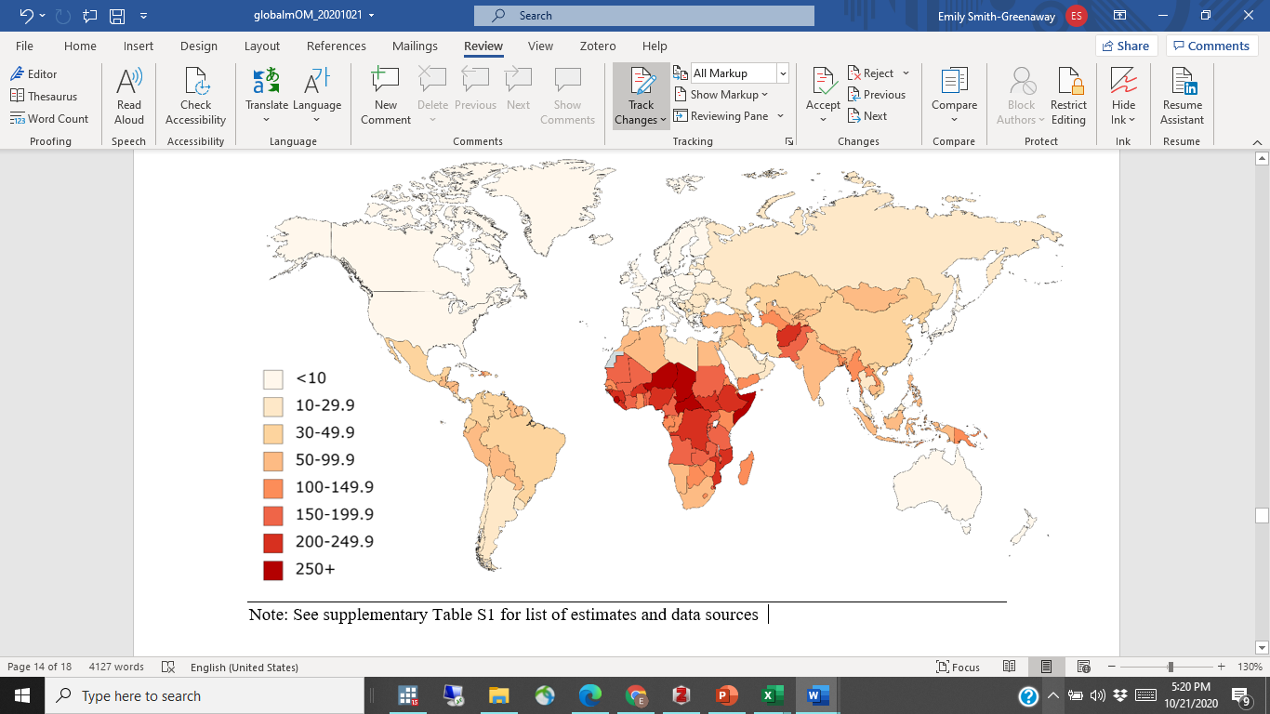

Note: See supplementary table S1 for list of estimates and data sources

**Figure 2. Maternal cumulative prevalence of infant mortality (mIM) for mothers age 45-49**

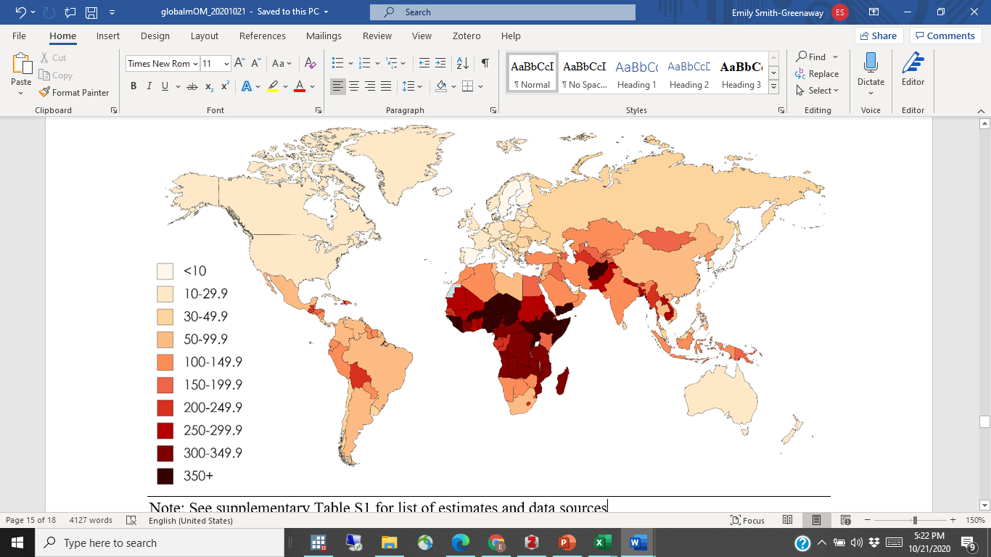

Note: See supplementary table S1 for list of estimates and data sources

Figure 3. Maternal cumulative prevalence of under 5 mortality (mU5M) for mothers age 20 to 44

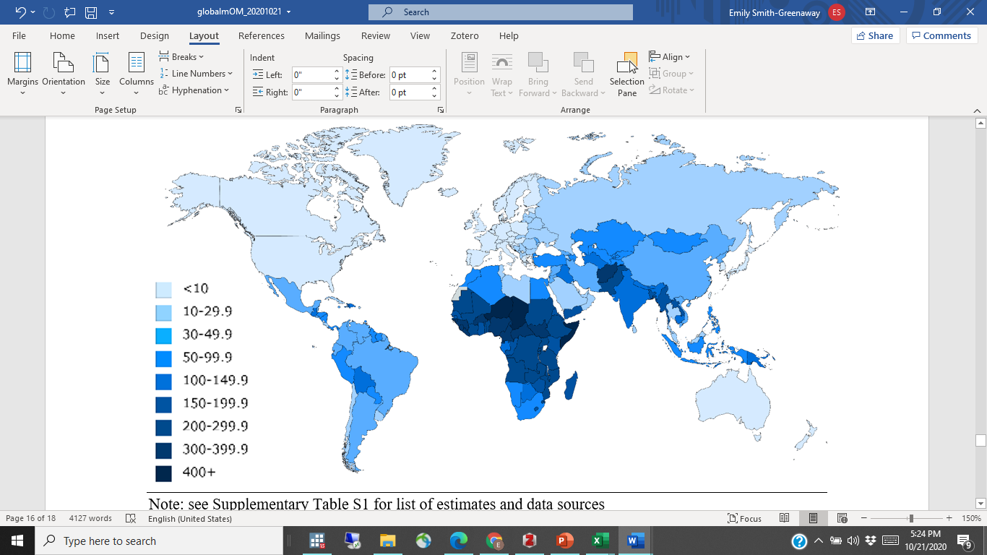

Note: See supplementary table S1 for list of estimates and data sources

Figure 4. Maternal cumulative prevalence of under 5 mortality (mU5M) for mothers age 45-49

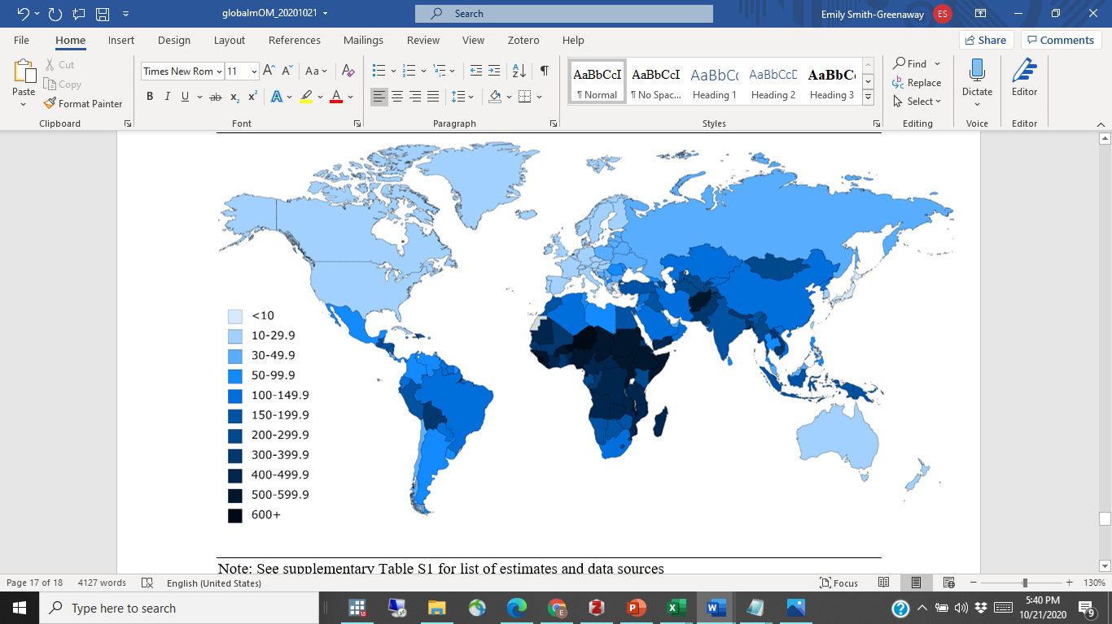

Note: See supplementary table S1 for list of estimates and data sources

Figure 5. Maternal cumulative prevalence of offspring mortality (mOM) for mothers age 45 to 49

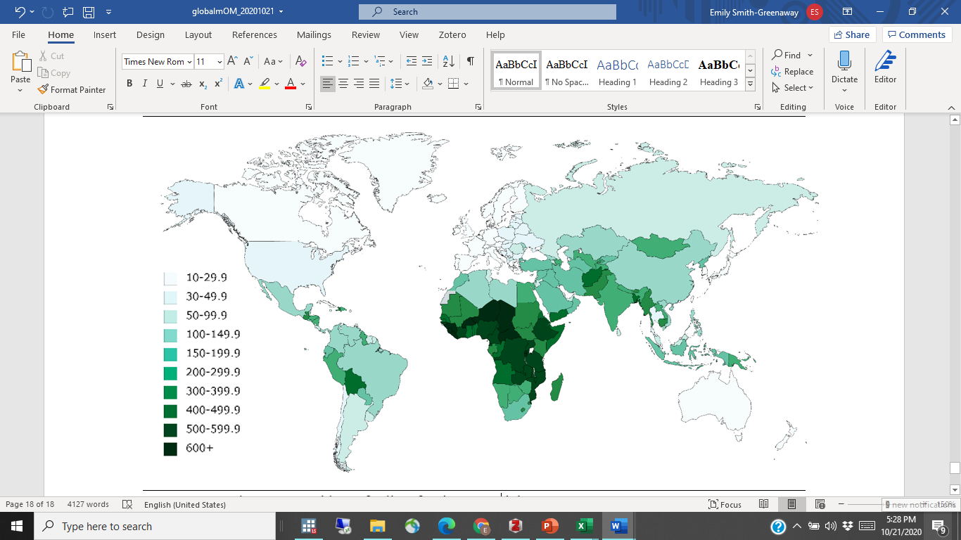

Note: See supplementary table S1 for list of estimates and data sources